**

**Recovery Month Celebration**

**~**

**~**

**Sat, Sept 24th**

**Join The Recovery Connection**

**for an open house, cookout,**

**ice cream truck, guest speakers, and games!**

DETAILS

Sat, Sept 24th

12 — 4 pm

The Recovery Connection

31 Main St. Marlborough MA 01752

Learn more about the center and

other resources during the celebration!

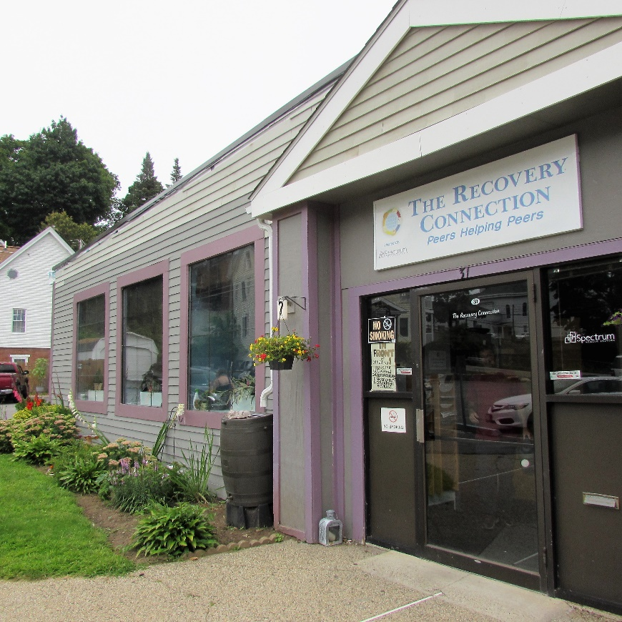

**

**The Recovery Connection**

*31 Main Street. Marlborough, MA 01752*

*Tel. 508.485.0298*

[*www.therecoveryconnection.org*](http://www.therecoveryconnection.org)